Exercise 3

Oregon Pink Shrimp Fishery Model

Define/articulate the Issue/Problem (focus the effort)

explicit purpose

Oregon’s Pink Shrimp fishing policies historically had regulated population by way of amount per boat, limiting the number of boast licenses, and season restrictions. They also mandate shrimp that average 160 per pound or larger are the minimum size. This causes the fishermen to move out of areas with higher densities of juveniles. I would like to explore the ramifications of the removal of the Trawling Vessel Number Restriction.

## Reference Behavior Pattern (RBP)

Oregon’s Pink Shrimp (Pandalus jordani) fishing fleet is comprised of 75 Double Rig Trawlers, (labeled “Vessels” in this model), which total 1051 trips from April 1 until October31. This allows the shrimps to repopulate during mating season which lasts from November until March.

* We will assume that trawlers have a 20-year span of usefulness.
* Shrimp live for a maximum of four years.
* Yearly shrimp mortality rate is high, so the bulk of catches are comprised of 2-year olds.
* The data concerning population of shrimps off of the Oregon coast is limited. I will, therefore use the 1966 data set from the State of California, Resources Agency, Department of Fish and Game, Fish Bulletin 155, D. Gotshall 1972. 950,000,000 Shrimp will be used as an initial value. I will split them to 600,000,000 Juveniles and 350,000,000 Adult shrimps.

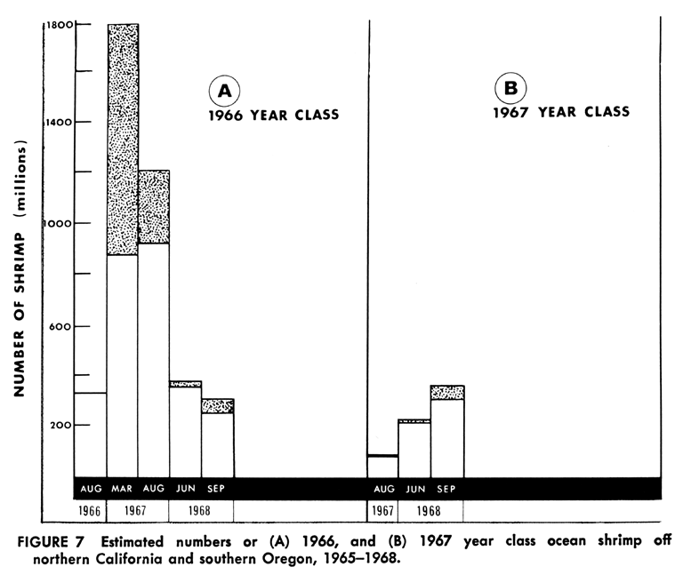

* Shrimp catch is normally highly variable. This will skew the data whose median we are trying to study, so I will normalize the catch across the last 30 years to 29 million pounds catch per year. (OFWS, http://www.dfw.state.or.us/MRP/shellfish/commercial/shrimp/landings.asp)

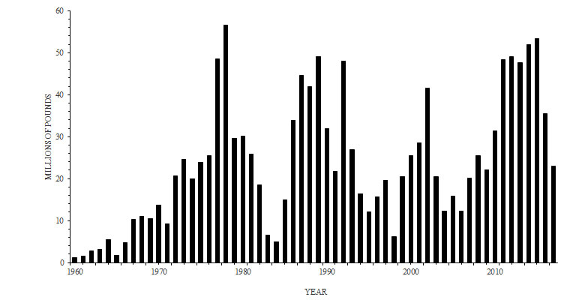

* All vessels have bycatch reducing devices, so bycatch will not be considered.
* Net hole size calibrates the minimum age of the target shrimp.
* The net holes and bycatch rejection grating are sized for shrimp in their 2 – 4 years.
* Shrimp Cost per pound will be averaged to $0.125/lb. (rounded from 0.125333 over the last 30 years).
* Initial Carrying Capacity is set for 1E010.

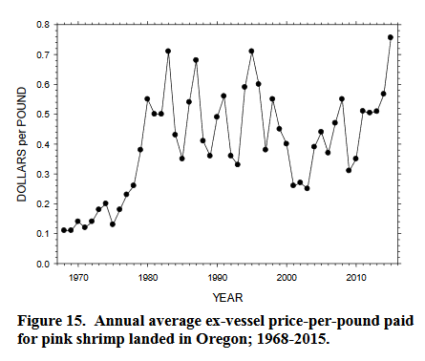

## Key Measurable Aspects

I will measure Adult Shrimp and Revenue per Vessel to reflect the impact of Carrying Capacity disrupting policy changes.

## Develop & Represent Dynamic Hypothesis[es]

I hypothesize that the depletion of Carrying Capacity will negatively affect both shrimp populations as well as Revenue per Vessel.

## Characterize Flows

**Shrimp** - Birth through Death

This is the life cycle of shrimp within a population. They are born as Juvenile Shrimp and mature 1 year to Adult Shrimp, whereupon they become breeding candidates. Not all adults breed at all times, so we have set that to about ½ of the Adults successfully procreate in a breeding season.

**Vessel** - Purchase through Retirement

This is the “life cycle” of a Trawling Vessel. The bank loans money with a payback period attached, and the vessel is purchased and set to work. The Vessel will last about 20 years and be retired. I am not tracking every vessel, I am simply retiring 1/20 of the vessels per year. That is to say: Trawling Vessels/20.

## ID feedback loops

* + - **Maturing Cycle**

Juvenile Fish 🡪 Maturing

* + - **Per Capita Birthing Cycle**

Juvenile Fish 🡪 Fish Population Density 🡪 Current Birth Fraction 🡪 Birthing 🡪

* + - **Life Cycle**

Juvenile Fish 🡪 Maturing 🡪 Adult Fish 🡪 Birthing 🡪

* + - **Mortality Impact Cycle**

Juvenile Fish 🡪 Fish Population Density 🡪 Current Death Fraction 🡪 Dying 🡪 Adult Fish 🡪 Birthing 🡪

* + - **Breeding Cycle**

Juvenile Fish 🡪 Maturing 🡪 Adult Fish 🡪 Fish Population Density 🡪 Current Birth Fraction 🡪 Birthing 🡪

* + - **Catch Impact Cycle**

Juvenile Fish 🡪 Fish Population Density 🡪 Catch Multiplier 🡪 Catch 🡪 Catching Fish 🡪 Adult Fish 🡪 Birthing 🡪

* + - **Death Cycle**

Adult Fish 🡪 Dying

* + - **Catching Cycle**

Adult Fish 🡪 Catch 🡪 Catching Fish

* + - **Catch Effectiveness Cycle**

Adult Fish 🡪 Fish Population Density 🡪 Catch Multiplier 🡪 Catch 🡪 Catching Fish 🡪

* + - **Population Density Driven Mortality Cycle**

Fish Population Density 🡪 Current Death Fraction 🡪 Dying 🡪 Adult Fish 🡪

* + - **Vessels Retiring Cycle**

Fishing Vessels 🡪 Retiring Vessels 🡪

* + - **Vessels Adding Cycle**

Fishing Vessels 🡪 Catch 🡪 Catch per Vessel 🡪 Revenue per Vessel 🡪 Payback Period 🡪 Adding Vessels 🡪

# Model of the 2016 Oregon Shrimp Fishing Fleet

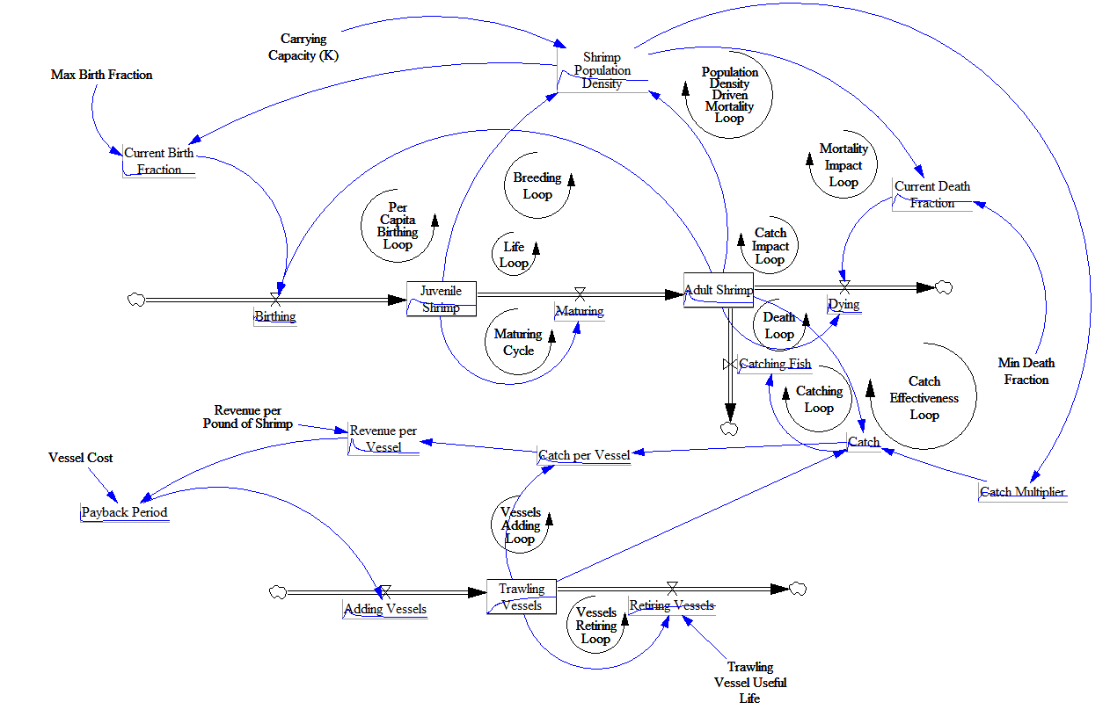specification and calibration (determine equations & parameters)

### Global Variables

* Total Simulation Time = 30 years
* Step Time = 0.25 year

### Shrimp

* Carrying Capacity, K=1e10
* Initial shrimp population, N(t=0) = 95e7
* Initial Juveniles = 6e8
* Initial Adults = 3.5e7
* Max. Birthing Fraction = 1
* Minimum Death Rate = 1/4 (at least 25% of the Shrimp population dies in any time period)
* Shrimp Population Density: (Adult Shrimp + Juvenile Shrimp)/"Carrying Capacity (K)"
* Current Birthing Fraction = Max Birth Fraction/Shrimp Population Density
* Birthing = (Adult Shrimp*Max Birth Fraction)
* Juvenile Shrimp = Birthing-Maturing
* Maturing = Juvenile Shrimp/2
* Time for Shrimp to mature: 2 years (if you use two storages)
* Adult Shrimp = Adult Shrimp+Maturing - Catching Shrimp – Dying
* Catch = Adult Shrimp*Trawling Vessels*Catch Multiplier
* Dying = Adult Shrimp*Current Death Fraction
* Min Death Fraction = 0.25
* Current Death Fraction = Min Death Fraction*EXP(Shrimp Population Density*2)

### Vessels

* Payback Period = Vessel Cost/Revenue per Vessel
* Initial number of Vessels: 75
* Vessels (Current number of active Vessels) = Adding Vessels-Retiring Vessels
* Cost of new vessel: $100,000
* Vessel useful life = 20 years
* Retiring Vessels = Trawling Vessels/Trawling Vessel Useful Life
* Maturing = Juvenile Shrimp/2
* Dying = Adult Shrimp*Current Death Fraction
* Catching Shrimp= Catch
* Adding Vessel = 10/Payback Period
* Retiring Vessels = Trawling Vessels/Trawling Vessel Useful Life
* Catch Multiplier = Shrimp Population Density*0.01

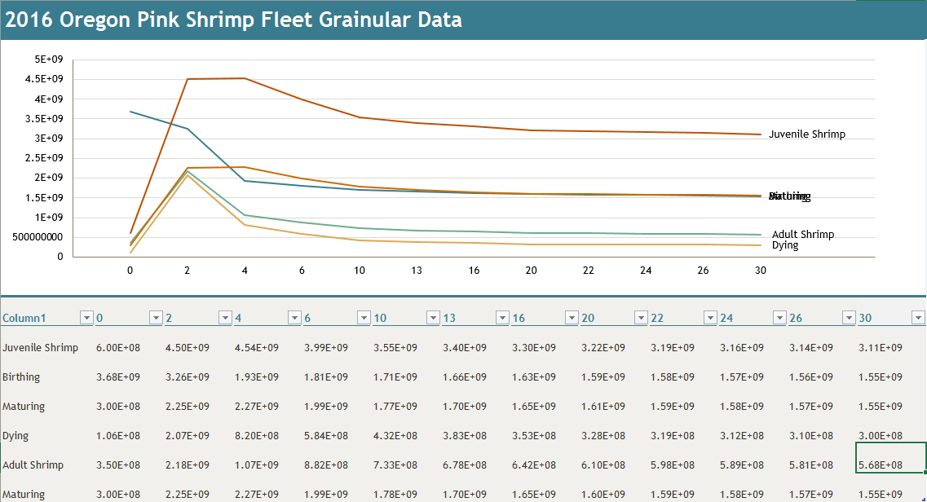

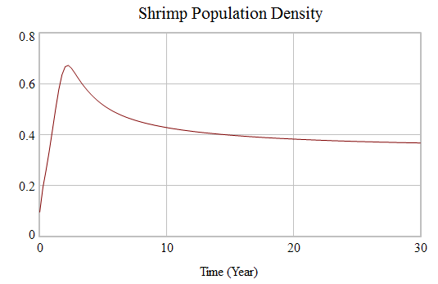

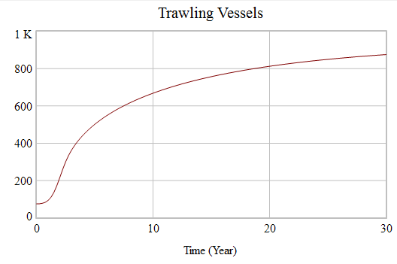

Test Model

## mechanical mistake tests

* I have tested and revised almost all equations. They should now be functioning correctly together.

## robustness tests

* I have increased the initial fish population to equal 9E9, and the same behavior was observed
* I have decreased the initial fish population to equal 1000, and the same behavior was observed

## diagnosing surprise behavior

* I am not seeing any behavior which I find surprising.

# Verification

## understanding model behavior/dynamics

We are seeing a classic rapid population growth to fill an available habitat and an equilibrium.

## hypothesis tests

I have run the model and my hypothesis seems to hold true.

# Validation

challenge the boundaries (extensive & intensive)

* I have changed the initial values of Juveniles and Adults, as well as the Maturation rate.
  + Changing Adults to 1E8 and Juveniles to 5E8 gave similar results. The equilibrium point remained the same.
  + Changing Adults to 5E8 and Juveniles to 1E8 gave similar results, the equilibrium point remained the same.
  + Changing Maturation Rate to Juvenile Shrimp/3 gave me an equilibrium point that was higher in Juveniles and lower in Adults, but that was expected

Model Application & Transfer

## Design and Evaluate Policies

* policy/theory
  + The operating policy set is simply that shrimp are born at a rate commensurate with the population density and the Adult breeding population. The breeding population is no more than 50% of the Adult population, and the Maturation Rate is set to allow for 50% of the Juvenile population to become Adults. The death rate is commensurate with the population density and the Adult population. We are unrealistically assuming that no Juveniles die.
  + Sensitivity
    - The maturation rate seems to be the variable most sensitive to change.
  + scenarios
    - We are studying the 2016 Oregon Shrimp Fleet.
* Make Learning Available (communicate)
  + develop a drama
    - The Oregon Fleet decides to remove the restriction on the number of Trawling Vessels allowed to fish for shrimp. I would like to experiment with the removal of the restriction on Trawling Vessels as a means to stress the Carrying Capacity.
    - My hypothesis is that we will see a general decline in number of shrimp until the populace is decimated.
    - This is indeed what we see  
      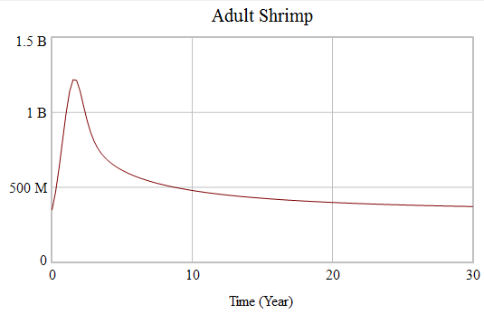
  + design a learning progression
    - We will experiment with deregulating the number of Trawling Vessels
    - We will experiment with changing the Carrying Capacity
    - Success will be defined by the identification of emergent patterns and properties, and the discovery of individual variable sensitivities and response patterns to variable changes.
  + implement a learning progression
    - To begin, the model will be created and tested.
    - Second, the baseline values will be entered and recorded.
    - The results will now be validated by the challenging of all known and/or expected limitations. In this case; we will expand the time horizon to 100 months, we will stock the shrimp population to and over carrying capacity, and we will minimize and maximize the maturation rate to find breaking points.
    - Finally, the variables will be methodically altered following tolerances and results recorded to establish patterns and/or properties as well as any emergent patterns/properties.

# Bibliography

Commercial Pink Shrimp Landings. (2017). Retrieved March 22, 2018, from http://www.dfw.state.or.us/MRP/shellfish/commercial/shrimp/landings.asp

Gotshall, Daniel W. “DEDICATION.” *Population Size, Mortality Rates, and Growth Rates of Northern California Ocean Shrimp, Pandalus Jordani, 1965 Through 1968*, State of California, Resources Agency, Department of Fish and Game, 1972, content.cdlib.org/view?docId=kt7580059c&brand=calisphere&doc.view=entire_text.

Hanna, Bob, and Steve Jones. “27th Annual Pink Shrimp Review.” *Annual Pink Shrimp Review*, Oregon Department of Fish and Wildlife, 15 Feb. 2016, digital.osl.state.or.us/islandora/object/osl:44313/datastream/OBJ/view.